Lab 4

- Please recreate this website using the assets supplied in webcourses. You will need to create a CSS file and a HTML file.

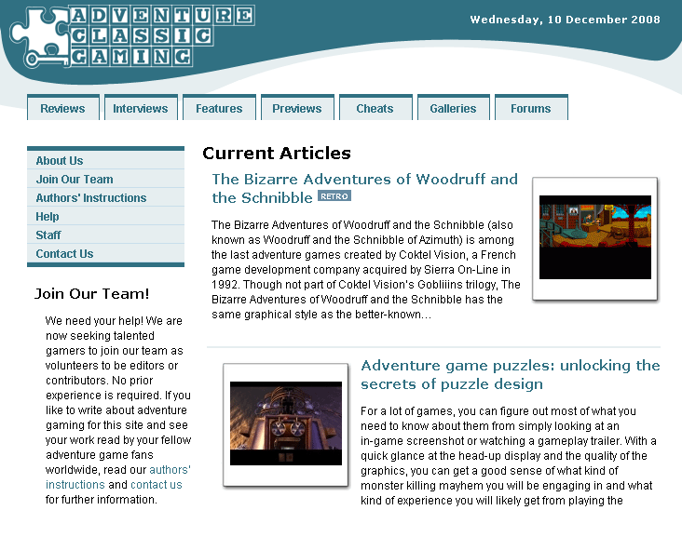

- Using JavaScript code below to recreate the page display the alert window box when the button was double clicked, and change the content in the box to “Hello, I am an alert box only show when you double click the button!”
<!DOCTYPE html>
<html>
<head>
<script>
function myFunction()
{
alert("Hello! I am an alert box!");
}
</script>
</head>
<body>
<input type="button" onclick="myFunction()" value="Show alert box" />
</body>
</html>

